Teamspirit Vol. 228 – January 2020

Cover story

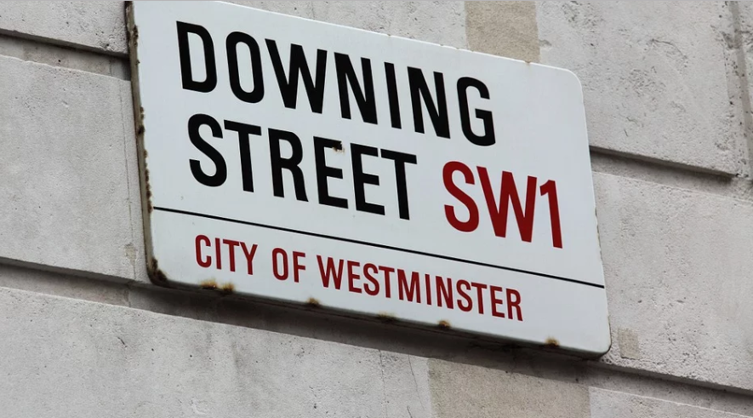

Campaigning on PIP during the General Election

When general elections come around, we try to raise our voices about the changes people with MS have told us are important to them.

To kick off the election campaign we launched a manifesto for MS, laying out our calls for the next UK government. This includes making Personal Independence Payments (PIP) make sense; creating a social care system that works for everyone; and ensuring access to cannabis-based medicines for people with MS.

We followed this by launching a campaign calling on the new Prime Minister to act now to change the often humiliating and degrading process of claiming PIP. Over 21,000 of you signed a letter in support of this and, in the coming weeks, we'll be taking this letter to Downing Street to tell the Prime Minister we can’t wait any longer.

As we go into the new year, we'll keep speaking up with everyone affected by MS. A new Parliament brings new opportunities for us to campaign on the issues we identified in our manifesto for MS, and more.

If you'd like to add your voice to our campaigns and tell us what matters to you, then please join our campaigns community via our website.

Contact: Emma Vasey, Senior External Relations Officer emma.vasey@mssociety.org.uk

Help, hope and voice

The Stop MS Appeal

The Stop MS Appeal launched publicly in October with a splash. Our TV advert has been seen at least 2.5 million times. It’s been shared by thousands in the MS community, shown on a range of national TV channels, appeared in cinemas around the UK and gained huge exposure through our partnership with the Telegraph.

To raise £100 million to find treatments for everyone with MS, we’re coming together as Team Stop MS. There are all sorts of ways you can get involved - whether through sharing the appeal in your group newsletter; painting your social media 'Stop MS'; or fundraising your own way!

Right now, Stop MS Champions are out and about taking the appeal into our communities. They’ll be working with local groups and talking to the wider community to spread the word and help raise vital funds.

Marion Riley, one of the Champions and Group Coordinator of the Chorley & Leyland Group, talks about why she’s become a Champion:

“It’s a really important time for us. The awareness has been created online and it’s really important to raise awareness of the Stop MS Appeal in our communities too. It’s a massive campaign and it needs all the support it can get. I’m looking forward to working with other groups to promote the appeal.”

To find out more about how you can get involved, including more about the Stop MS Champions, visit https://www.mssociety.org.uk/get-involved/fundraise/stop-ms/team-stop-ms.

Contact: Campaigns Team
campaigns@mssociety.org.uk

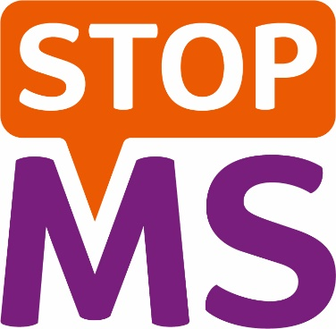

Sativex on the NHS – an important step

The National Institute for Health and Care Excellence (NICE) has approved Sativex – a cannabis-based medicine – to be widely available on the NHS in England for people with MS who experience muscle spasms, when other treatments haven’t worked.

Together we’ve been campaigning for access to Sativex across the UK. Hundreds of people with MS have shared their experiences with NICE about why medicinal cannabis is so important.

It’s brilliant that NICE has finally listened.

But while these guidelines are a good first step, they don’t go far enough.

Sativex is licensed for moderate to severe muscle spasms. We need to see cannabis-based medicines approved for use in pain for those who could benefit.

This announcement doesn’t come with funding, meaning access in England will depend on local NHS funding decisions. And, while Sativex is already available in Wales, the decision won’t apply to Scotland or Northern Ireland.

We need to see Sativex on the NHS across the UK. And we’ll be working with local bodies to call for swift access across the country.

We won’t stop campaigning until everyone with MS who could benefit from medicinal cannabis can access it on the NHS, no matter where they live.

Find out more about the decision and what it could mean for you on our website.

And visit this link to join the campaign: mssociety.org.uk/campaigns

Contact: Campaigns Team campaigns@mssociety.org.uk

Siponimod recommended for secondary progressive MS

In November 2018, a European committee (the Committee for Medicinal Products for Human Use) recommended siponimod to be approved as a treatment for people with active secondary progressive MS.

Siponimod could be the first oral disease modifying treatment (DMT) licensed in the UK for secondary progressive MS. This is an exciting step forward for MS treatment. It means the drug is likely to be licensed by the European Medicines Agency very soon.

The next step is for UK health bodies to decide whether siponimod should be available on the NHS. We’ll be working hard to make sure that happens as soon as possible. But the process can take some time, and we don't expect a decision until the middle of 2020.

Siponimod hasn't been recommended for everyone with secondary progressive MS. It's only been recommended for people who have evidence of inflammatory activity on an MRI scan and/or still have relapses.

There may be further restrictions like how long you've had MS for, and the level of your disability. We won’t know these in full until the licence is published.
You can find updates on siponimod on our website.

Contact: Jonathan Blades, External Relations Manager
jonathan.blades@mssociety.org.uk

Bikers saddle up for another success!

We are sending a big thank you to the groups who met up with Bike the UK for MS riders this summer.

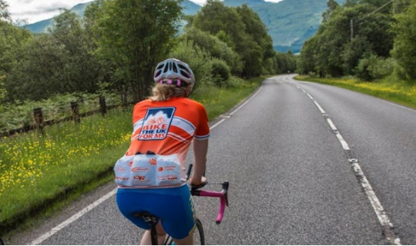

Feedback from the riders who cycled from Land’s End to John O’Groats, or across England, about their links with MS Society members was again excellent

For many of them, meeting local group members was a highlight of the journey and helped remind them why they took on such an amazing challenge.

Collectively they raised a superb £29,000, to be split between the local groups they met and MS research.

Recruitment is now underway for the 2020 events. Please tell anyone who may be interested to visit www.BikeTheUKforMS.org.

Contact: Andy Jarrett, Area Fundraiser
andy.jarrett@mssociety.org.uk

My MS Walk – David’s Story

My MS Walk was launched earlier this year, and the response from you has been fantastic! Thank you so much to everyone who held a My MS Walk and helped to raise over £85,000 for the Stop MS Appeal.

The walks were of all shapes and sizes, from big walks in local parks to some beautiful coastal walks, but every My MS Walk raised money for vital MS research.

David Allen, Vice-Chair of the England Council, worked with his local Parkrun in Luton to hold a fantastic event which raised over £2,600! Here is David’s story:

“I wanted My MS Walk to bring the community together but I had no idea how I was going to achieve it at first until I contacted one of the co-event directors of my local Parkrun. It was then everything fell into place.

They had the course and the volunteers. All I had to do was agree a date, set up the fundraising and registration pages and then promote on social media. The first My MS Walk Luton was a huge success and I was blown away by how many people got involved, with over 100 taking part.”

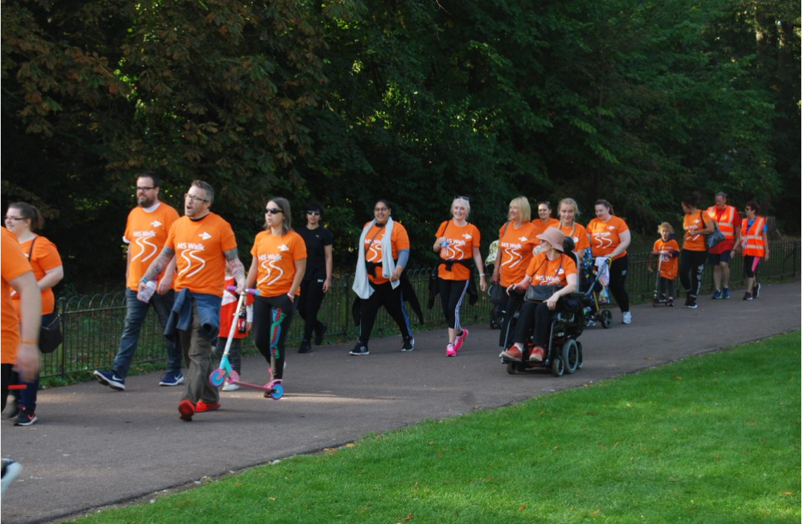

You can get involved in 2020 and walk, roll or stroll to stop MS at any time of year. Whatever you do, we’ll be with you allthe way. More details can be found at www.mssociety.org.uk/my-ms-walk.

Contact: Joe and Gus, MS Walk Team
mswalk@mssociety.org.uk

Finding my community
We spoke to Amy Thompson from our Trafford and South West Manchester Group about her experience of being diagnosed and finding her MS community.
“When I was first diagnosed, I struggled to find young people like me who I could speak to about my MS. I soon found support from my local MS Society group and became a volunteer, but, although I adore the group, they are all older than me and we are obviously in different stages of our lives and our journeys with MS.
It got me thinking that that there must be other young people like me across the UK who might not have anyone who they can relate and talk to. I began a blog about my experiences and decided that I would use it as a platform to reach out and bring young people with MS together. This started off really small. There were six girls who reached out to me because of my blog, asking for advice or to tell me how much my blog had helped them. After getting to know them, I asked these girls individually if they would like to be part of a group with other young likeminded people.
After chatting for a few months and getting to know each other I arranged our first meet-up. Only three of us could attend but we went for an afternoon tea in Birmingham and we had the most amazing day. It was like we had been friends for years. Yes, we talked about how rubbish MS is but we also talked about other things too - we laughed, we joked and we ate too much cake! Since then the group has more than doubled. There are 27 of us now and I can't wait to meet the rest of them!
I currently facilitate this group solely on social media platforms. We have a Facebook group page where we post our stories and discussion points, chat, gossip and occasionally talk about MS. There is also a Whatsapp group chat which we re-named ‘Multiple Savages’ because for the most part, we all just joke around and have fun! It’s completely up to each individual to choose what they want from the group; the main thing is that it’s a safe and supportive place for young people with MS and people can choose how they want it to help them.
I think it's so important to get young people talking. Most of the group members have said how they'd never really talked about their illness before or how they've hidden it from friends and family. But now, I would like to think, they have a place to talk about anything that is on their minds.”
We are working with Amy and others on some exciting ways to help people make social connections and find their own MS communities. Watch this space!
CONTACT: Amy via her blog at www.butyoudontlookill.com

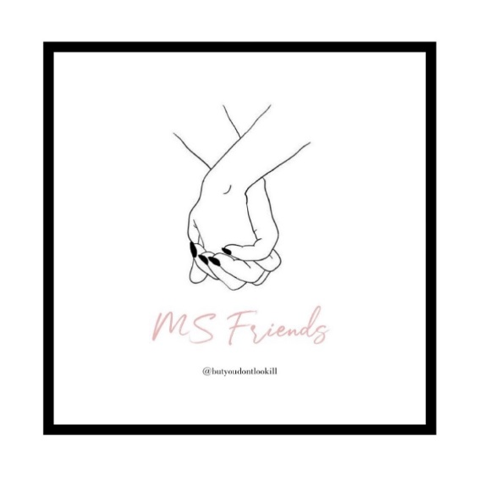
Information for your group

Health and Safety Policy update – 2020

We all know that health and safety law protects us every day, but it can often be difficult to understand your individual responsibilities for keeping others safe. For help and support with this, you should read our Health and Safety Policy.

This is a statement outlining our commitment to meeting health and safety standards which has recently been reviewed, updated and approved by our Executive Group and Board of Trustees.

Please visit the links below:

Statement of Intent: https://volunteers.mssociety.org.uk/resources/439

Health and Safety Policy: https://volunteers.mssociety.org.uk/resources/health-safety-policy

Contact: Jo Duffy, Head of Health and Safety
jo.duffy@mssociety.org.uk

New information resources available

The Information Resources Team have been working hard to update and review a number of booklets and also create some new resources.

The following booklets have been updated this year. You can order up to 50 copies of each from the online shop www.mssociety.org.uk/onlineshop ). The latest publications catalogue (BK00) is also available.

- Just diagnosed - BK24 - Jan 2019
- Managing your relapses - BK05 - Nov 2019
- MS and your bladder - BK30 - June 2019
- MS and your eyes - BK26 (also available in a large print version) - BK26LP – Aug 2018
- Work and MS – an employee guide - BK01 - Jan 2019
- Pain and unpleasant sensations - BK29 - Oct 18
- Disease modifying therapies (DMTs for MS) - BK03 - July 2019

Please recycle any old versions of the booklets and replace with the new ones.
New resources include factsheets that can be download from the website:

- Fasting and MS - FS09
- Genes and MS - FS02
- Ocrelizumab - FS29
- Cannabis and MS - FS30

There is also a handy credit card leaflet that gives details about all our services and support; How we can help you - CC04.

Thank you for distributing all our booklets and leaflets. You help get them to the people who need them most.

Contact: Carmel Barrett, Information Resources Manager
carmel.barrett@mssociety.org.uk

Membership renewals

Just a reminder that members should only be paying their subscriptions for one year at a time. Please don’t accept any payments for beyond the end of 2020, in case our membership offer (which is under review) changes in the future.
Contact: Supporter Care Team
supportercare@mssociety.org.uk or 0300 500 8084

Support for volunteers

Restructures in our Executive Group
You may have seen on the volunteer website in December that we have made some changes to our Executive Team. This will be coming into effect this month so we’d just like to highlight this again.
What does this mean?
These changes shouldn’t affect day-to-day activities. You’ll still be able to contact Supporter Care and your local staff, including LNOs.
The Volunteering Team will actually be moving into the same directorate as the Local Networks staff, which will improve decision making, process and efficiency.
For a full list of the new structure and new directorates, please visit the volunteer website here: https://volunteers.mssociety.org.uk/news/2019/12/changes-our-executive-team.
Further information
If you have any questions or concerns about this and how it may affect you or your role, please contact Supporter Care.
CONTACT: Supporter Care Team
supportercare@mssociety.org.uk or 0300 500 8084

Fundraising forums and training 2020

The Area Fundraising Team are pleased to announce 2020 dates for the popular Fundraising Forums. These are helpful, peer-support meetings for any group volunteer involved in fundraising, run through the easy-to-use Zoom online app.

Book via this link: https://volunteers.mssociety.org.uk/events/2019/fundraising-forum-zoom-session.

2020 meetings:

- Thursday 19 March – 12 to 1.30pm

- Tuesday 12 May – 6 to 7.30pm

- Thursday 16 July – 12 to 1.30pm

- Tuesday 15 September – 6 to 7.30pm

- Thursday 12 November – 12 to 1.30pm

We’d also like to invite you to try our eLearning Module about Awards for All. This has been written in collaboration with volunteers with experience in submitting successful Award for All funding bids. Find out more by visiting https://volunteers.mssociety.org.uk/awards-for-all.

Contact: Simon Moran, Area Fundraiser
simon.moran@mssociety.org.uk

Finance

2019 Year End

Happy New Year from the Finance Team!

We are very grateful for all of your support throughout 2019. It wasa fantastic year and the progress made by all groups with the 2019 year end has been impressive!

However, the 31 January 2020 deadline is fast approaching. If your group are yet to submit 2019 Year End reports to National Centre, and require further assistance, please don’t hesitate to contact Finance Support as soon as possible.

We are here to help, and can assist with your queries, including:

- Resetting online accounting login details
- Providing remittances for transfers from MSNC
- Providing guidance on the analysis of transactions if you’re unable to locate supporting paperwork
- Correcting any transactions you may have analysed incorrectly

Contact: Finance Support Team
financesupport@mssociety.org.uk
0131 335 4078

Cheque imaging and referrals

Since July, banks have been exchanging digital images of cheques within the UK for clearing and payment. This has significantly reduced the timescales involved, so that a cheque paid into or out of an account will clear at 23.59 the next working day. However, this has also led to an increase in cheque fraud.

Banks are being extra diligent in referring cheques back to us to confirm that the details are correct and a cheque is OK to be paid. We only have limited time to respond to these referrals. This is usually around an hour, but can sometimes be as little as 20 minutes. A member of staff from the MSNC Finance Team will contact a group to confirm the details of a cheque. Barclays will not contact groups directly.

Unfortunately, if we are unable to confirm by the deadline that the cheque is OK to be paid, it may be returned unpaid.

Cheques can be referred for multiple reasons, such as:

- Signature differs
- High value (£50K)
- Not signed in accordance with the mandate
- Words and figures differ
- Alteration requires full signature

It is important that all cheques issued from a group’s account are fully completed and signed by two signatories on the current bank mandate.

We are also seeing an increase in unpaid cheques deposited into accounts due to being incomplete. Please ensure that all cheques paid into your account are fully completed and signed.

Contact: Treasury Support Team
treasury.support@mssociety.org.uk

Finance Zoom sessions

Back in 2019 we launched our first Finance Support Zoom sessions, focused on the Year End process.

There was a fantastic uptake, with coordinating team members from over 40 groups attended. It was wonderful to meet so many of you.

Looking ahead, we would like to extend these sessions in 2020 to cover different aspects of finance. We already have a few ideas in mind, including:

- Planning and budgeting
- Use of funds
- Use of online accounting

It would be great to tailor these sessions to your ideas and preferences, so please let us know which topics would be helpful.

Contact: Finance Support Team
financesupport@mssociety.org.uk
0131 335 4078

Our groups and services

Sell-out music festival raises over £4,000 for the MS Society Ayrshire and Arran Group

Last year, Tom Murray decided to use his passion for music to organise TomFest 2019 in support of the MS Society Ayrshire and Arran group, and raised more than £4,000!

Tom had organised the festival three times previously, including for Alzheimer’s Society and Parkinson’s UK. TomFest had grown in reputation and popularity, and, after the success of the festival in 2018, Tom had several requests to run the event to fundraise for people affected by MS in the area.

Ticket holders were able to enjoy live music from bands Memphis, The Usual Suspects, Trunk Monkey, Wildcard, The Dead Flowers, Jeremiahs Sons and Slider, as well as a rock DJ set from Ian McAdam. Local businesses supported a popular raffle, with prizes from hotels, travel companies and artists.

Jennifer Bryson, Group Coordinator, said:

“We were absolutely thrilled Tom held TomFest 2019 in support of the MS Society Ayrshire and Arran Group.

The vision of our local group is to support and enhance the lives of those living with MS in Ayrshire and this wouldn’t be possible without the continued support of our local communities and events such as this. We can’t thank everyone at TomFest enough!”

Contact: msfundraising@mssociety.org.uk

Golfers stopping MS

Many people like nothing better than a round of golf and are heavily involved in the sport and their local club.

We are always delighted when golf captains choose the MS Society as their charity of the year. But if your group has links with local golfers, don’t wait for them to come to you. Why not consider proactively approaching them to see if they could choose to help grow the group’s income? Perhaps they could arrange an annual golf day on behalf of your group.

Help and support for doing this is available from your local Area Fundraiser so why not give it a go in 2020?

Contact: Your Area Fundraiser
https://volunteers.mssociety.org.uk/area-fundraisers



Barnsley Group anniversary celebrations

Our Barnsley & District Group was proud to celebrate a milestone last November. It was 50 years since they broke away from the Wakefield & District Group and struck out on their own, soon establishing many of the popular events which still take place today, including the Autumn Fayre (now Summer Ball), Mayor’s Parade and Christmas Dinner.

Today, the group continues to work hard to support its members through fundraising, social events and grant-giving. The outstanding contribution of three Coordinating Team members (Kath and Martin Connelly, and Susan Baker) was acknowledged at the anniversary celebrations. They each received a ‘Shining Star’ award in recognition of the years they have spent volunteering for the benefit of the group and its members.

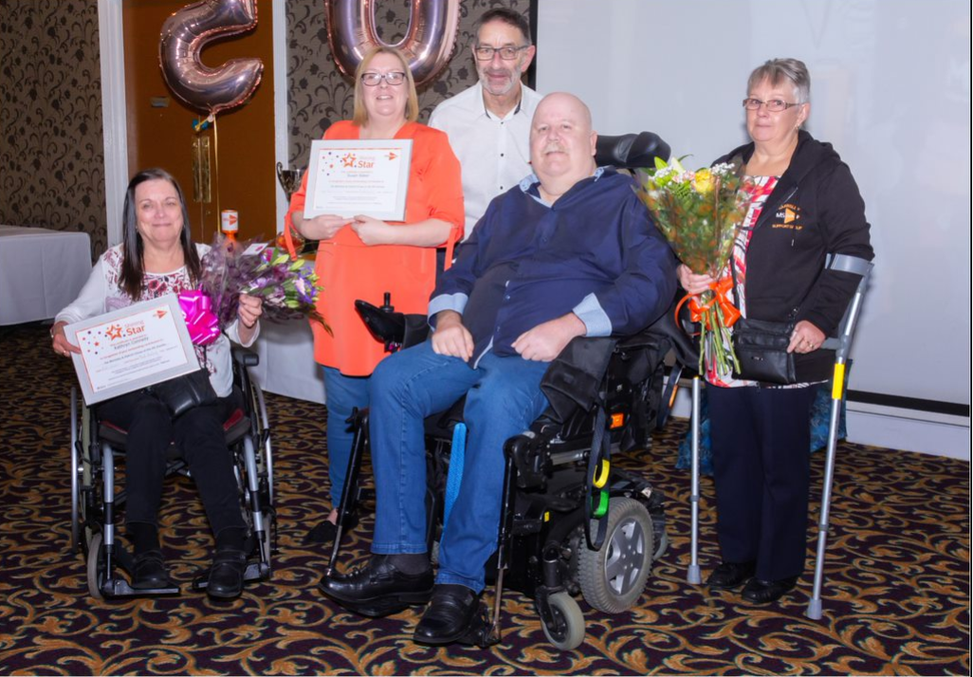

Group activity on the Isle of Wight

Thanks and congratulations to our dedicated volunteers on the Isle of Wight, who have been nominated for a Queen’s Award for Voluntary Service. Here’s a flavour of what they were up to at the end of last year:

Fun at the Christmas Fayre
“On 23 and 24 November, we had a stall at the Christmas Fayre at the John Chiverton Centre in Newport. The Centre is there for anyone living with, or affected by, any potentially life-limiting illness.

It was a very enjoyable and successful event where we raised nearly £430. We had lots of raffle prizes, hand-made Christmas cards for sale, and a ‘Guess the weight of a huge MS Christmas cake’ competition. Great fun was had comparing the weight of the cake to people’s small children (and the occasional elf…).

As always, we had many people wanting information about MS and the Island Group. It is very rewarding to be able to talk to, and hopefully help, someone new.”

Reaching out
“On 16 November, we held a ‘Living Well with MS’ day to showcase our services and try to reach more people who are affected in some way by MS.

Over 80 people attended, including several who were making their first contact with the Society. One young lady had only been diagnosed with MS the day before. Over 20 volunteers were on hand to answer questions and ensure everything ran smoothly, with a very relaxed atmosphere.

Two NHS MS specialist nurses were kept busy answering questions from a steady stream of people. Dr Sorrel Bickley spoke very encouragingly about the direction and speed of current research, and Stuart Nixon MBE (an ambassador for the Society) was very inspirational. He was, in his own words, ‘blown away’ by the whole event - particularly the feeling of community within the group.

The day could be summed up by the number of people who thanked us just for being there for them.”

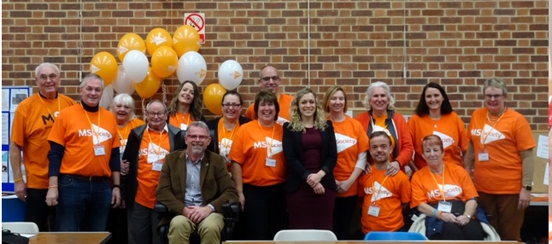

If your group would like to organise an event like this, please contact your LNO.

For England

England Council welcomes new members

We recently said goodbye to England Council members Lynda Tubbs and John Pullin, sending them off with an MS Society ‘Shining Star’ award in recognition of their work to help people with MS.

We are pleased to welcome the following new members:

- Ben Ajayi-Obe works in the media and broadcasting industry as a data scientist. He has been aware of MS since his mum was diagnosed when he was eight. He is a dedicated fundraiser, taking on challenges such as running a half marathon while pushing his mum in a wheelchair, and breaking a world record on an indoor rowing machine. Most recently, Ben co-founded a team of four who successfully rowed 3000 nautical miles across the Atlantic Ocean, without the use of an engine or sail. This endeavour raised approximately £35,000 for MS.

- Helen Cherry was diagnosed with MS 14 years ago whilst working as an Occupational Therapy Support Worker in a neurological unit specialising in acquired brain and spinal injury and MS. After retiring on medical grounds in 2011, Helen decided to volunteer for the MS Society and trained to become a Lead Support Volunteer for the Plymouth & Tamar Valley Group. In January 2017 she became Group Coordinator, and worked to expand the support they provide to those with MS in the local area. Helen is involved in various steering committees with the NHS and local authority, where she provides advice and guidance from an MS point of view.

For Northern Ireland

Stop MS - NI

The Stop MS Appeal presents us with a huge challenge but also a fantastic opportunity to stop MS in its tracks and transform people’s lives.

We have been busy recruiting Stop MS Champions, whose role will be to help create awareness about MS and the Stop MS Appeal in their community. They will speak to individuals, groups, local organisations and local press about the appeal and our ambitions. If you are interested in finding out more about becoming a Stop MS Champion, please get in touch.

We would like to take this opportunity to thank those who have stepped forward already. We would also like to thank our amazing groups, especially those that have made donations to the appeal. Our Belfast Group donated £2,500, our Fermanagh Group £2,000, our Mid Ulster Group £5,000 and our Coleraine Group £1,000.

We would encourage all our groups to think about how they can get involved in 2020.

Perhaps your group would consider organising an extra event or an event specifically to raise funds for the appeal. We can support you with that. Or you could approach a local company, sports club or organisation about organising an event for the appeal. Please let us know if you have any ideas or would like to discuss how your group can get involved in the appeal.

Mind My MS project - register your interest now!

We are busy planning the launch of our brand new project called ‘Mind My MS’. We are really excited to be working on this Big Lottery funded project over the next two years.

Mind My MS aims to help people in the Mid and East Antrim area live well with MS. This will be achieved through cafes, mindfulness activities and counselling sessions. We hope the project will give people who live with MS an opportunity to connect with others, improve emotional wellbeing and learn new techniques to help manage their MS.

Do you have a connection with MS? Would you like to make a positive contribution? We are currently recruiting volunteer hosts for our new community cafes. We are asking for volunteer hosts to provide a warm and welcoming environment for others to come along and make connections. The cafes will be held once a month in cafes and coffee shops within the Mid and East Antrim area.

CONTACT: Rachel Creighton, Project Coordinator
mindmyms@mssociety.org.uk

Fundraising events in 2020

We are organising somegreat events and activities for 2020. There will be lots of opportunities to get involved and your group can be part of that. You can raise funds for your group by recruiting people to take part in our events. We offer things like abseiling, zip wire challenges, skydiving, mountain walks, runs and a host of other activities. Or why not get involved in our new Big Breakfast fundraiser. Organise a breakfast at home for family members, friends and neighbours, or at work for colleagues, and ask them to make a donation. It’s really quite simple. You can then encourage one of your guests to host the next Big Breakfast for MS.

Partnerships
We work with some amazing partners and we are really keen to expand and develop this programme in 2020. Do you know a company that might be interested in supporting the MS Society as a corporate partner? We are keen to speak to people about MS and you can help us with introductions. Ultimately we hope that a company will become a partner but, initially, we want to create awareness and understanding around multiple sclerosis.

Contact us if you have any contacts in the corporate sector that we could talk to. It might be a local business owner you know or even the organisation you work for.

Contact: Tom Mallon, Fundraising Manager
tom.mallon@mssociety.org.uk

New Council member for 2020
We are delighted to welcome a new member to the Northern Ireland Council in 2020:
- Tom Hunter served on the NI Council from 2013 to 2018 and is now stepping back into the role in 2020. Tom was diagnosed with RRMS over 11 years ago. Previously working in London city as a broker, Tom retrained as a counsellor/psychotherapist and went on to set up the volunteer counselling service for the MS Society NI. Tom was awarded the MS Society Volunteer of the Year in 2017.

We have one member leaving the NI Council. Siobhan Allister served on the Council for six years and was awarded an MS Society ‘Shining Star’ award at our recent Volunteer Awards at Belfast City Hall.

For Scotland

Social security in Scotland

It’s been really busy behind the scenes as we’ve worked with other organisations to improve the proposals by the Scottish Government for the benefits being devolved to Scotland from the UK Government.

In the spring we asked for your help in replying to a short survey based on the Scottish Government’s consultation on ‘Improving Disability Assistance in Scotland’. A fantastic 550 people completed the survey. We used the wealth of evidence gathered to inform our formal consultation response, using many of your quotes to highlight areas for improvement.

We also used your stories at stakeholder meetings with the Cabinet Secretary for Social Security and Older People, to talk about the changes that need to be made to improve the system.

Last month the Scottish Government led a debate in the Scottish Parliament to mark its official response to the consultation. We again used your stories to paint a picture for MSPs in the briefing we supplied for them ahead of the debate. This meant we received a high number of references from MSPs during the debate who quoted what you had told us. You can find the official report on the debate at http://www.parliament.scot/parliamentarybusiness/report.aspx?r=12327&i=111399.

The work continues and we have joined the Scottish Campaign on Rights to Social Security to work with other organisations to improve the system. We will continue to engage with politicians and civil servants to make our voice heard in the coming months.

Contact: scotlandcampaigns@mssociety.org.uk

What makes a good MS service? Share your views

We’ve started a long-term piece of work to look at the services provided to the MS community across Scotland and we want your views! Our initial work has seen us hold meetings in Melrose, Stirling and Glasgow to ask people affected by MS to tell us about their experiences and expectations ranging from: support services; diagnosis; review of care; care co-ordination to treatments.

In light of the General Standards for Neurological Care and Support, published in March 2019 and the Neurological Action plan published in December 2019, this work is timely. The 90-minute sessions we are running are being used to test whether or not you agree with our assumptions about services, to fill in the gaps of understanding of what a good service looks like and to understand your priorities for treatment and care.

In 2020, there will be lots of opportunities for you to get involved and have your say as we continue with this work. There will be Zoom meetings on individual topics where anyone (with access to the internet) will be able to dial in, and we will continue to hold meetings around the country as the work progresses and takes shape. If you think your group or people in your community would like to help us hold a meeting then please let us know.

CONTACT: scotlandcampaigns@mssociety.org.uk

New Council member for Scotland
We are pleased to welcome a new member to the Scotland Council:
- Maxine Thompson was diagnosed with MS in her mid-thirties, and is studying Senior Honours in Social Sciences at the University of Glasgow. She was previously awarded a Policing West Mercia Performance Group Certificate of Achievement for her leadership work in coordinating the private, public and voluntary sectors to work together and support vulnerable people in Herefordshire.

Maxine already helps the MS Society with local fundraising and media relations, and has independently raised a question at Parliament about the PIP assessment process. She wants to use her position as a Council Member to champion the way society views the abilities of those living with MS, and to highlight the financial difficulties they can face.

New Year’s resolutions: Join us at Edinburgh Marathon Festival 2020

As we’re beginning the new year, we’re also gearing up for Edinburgh Marathon Festival, our biggest fundraising event of the year in Scotland! It takes place this year on 23 and 24 May, and we’ll be there cheering each and every one of our amazing #MSSuperstar runners, with the support of our dedicated volunteers.

Last year, we had more runners than ever before, with more than 180 people running to help us stop MS, including MS Society Scotland’s National Council members.

Laura, a National Council member, said:

“I wanted us to do the 5K at Edinburgh Marathon Festival because I felt we had a responsibility to demonstrate our determination and tenacity to the MS community.

Everyone is impacted differently by MS and it’s the work of the MS Society that enables many people to live as full a life as possible.

We did this challenge for the more than 11,000 people living with MS in Scotland, our friends, our families and ourselves.”

Will you be joining us at EMF 2020? Choose your distance from the marathon, half-marathon, relay, 10K and 5K events. There are also junior distances of 5K, 2K, 1.5K and a kid’s kilometre, making this a fun event for the whole family!

If you’d like to join the MS Superstars, visit: https://www.edinburghmarathon.com/.

Contact: msfundraising@mssociety.org.uk

Back by popular demand - our Forth Rail Bridge Abseil

We’re really excited to share that not only will our Forth Rail Bridge Abseil be back in 2020 due to high demand, but we’ll be holding the event on 14 June to take advantage of the limited Scottish sunshine! Join the MS Superstars team for this unforgettable challenge and abseil 165ft down one of Scotland’s most iconic landmarks to help stop MS.

See www.mssociety.org.uk/get-involved/fundraise/adrenaline/abseiling/forth-rail-bridge-abseil.


Last year, Claire Purdie, MS nurse for Lanarkshire, faced her fear of heights to fundraise for the MS Society Lanarkshire Group.

Claire said:

“The MS Society Lanarkshire Group are very active and we rely on them a lot for providing support, information and counselling in Lanarkshire.

They’re a lifeline to a lot of my patients with MS and taking part in the abseil
was just one small thing I can do to give back.

MS is so close to home for me. When I first worked in neurology it was just a diagnostic and support service. The advances that have been made in research and disease modifying therapies (DMTs) have been spectacular.”

A huge thank you to Claire for facing her fears to support the fantastic work of the MS Society Lanarkshire Group!

CONTACT: Fundraising Team
msfundraising@mssociety.org.uk

For Wales

New Council members for 2020

We are delighted to welcome four new members to the MS Cymru Council in 2020:

- David Roberts has lived with RRMS for 34 years. He had a lengthy engineering career (from plant electrician to Engineering Manager UK & India), which he attributes to adopting a positive mental attitude. Now retired, David has time to give something back, and is both Health & Safety Volunteer for the Torfaen Group and a Champion for the Stop MS campaign.

- Meg Kingston lives with her husband and cats in the Rhymney Valley, and has had MS for nearly 30 years. Meg worked in IT and mobile telecommunications for more than a decade with steadily worsening symptoms and has been working as a writer since “retiring” - with significant success. She believes it’s important to recognise the achievements and variety of experiences that members have, and for the Society’s councils to involve a good cross-section of the MS community.

- Marion Davies was diagnosed with MS in 1997. Her career was in town planning and economic development, working for local authorities in South Wales and the Welsh Assembly Government. She hopes that the skills she has developed in research, public consultation and public speaking will be helpful to the work of the Cymru Council. Marion is now happily retired and has the time to support and help causes she feels passionately about.

- Susannah Robinson has been involved with the MS Society Gwynedd a Mon group for almost 20 years, since a very good colleague was diagnosed with MS. During her time with the group she has been Treasurer and Group Coordinator, as well as being heavily involved with support. She will be a strong voice for North Wales on the Council.

Zip it to stop MS!

Join MS Society Cymru on 6 June, as we conquer our fears to raise vital funds for the Stop MS Appeal by taking on ‘Velocity 2 – The World’s Fastest Zipwire’.
Set within the breath-taking scenery of Snowdonia National Park, you’ll enjoy the freedom of flight, travelling at speeds of over 100 mph!
It’s just £50 to register, with a minimum fundraising target of £150. Sign up online at zipittostopms-mscymru.eventbrite.co.uk.

We can see a future where nobody needs to worry about MS getting worse. We believe we can stop MS, and you can help by signing up to ‘Zip it to stop MS’ today!

CONTACT: Sian Dorward, Fundraising Manager
sian.dorward@mssociety.org.uk

Focus on the Information and Support Volunteers in Wales

Louise is an Information and Support Volunteer with the My MS, My Rights, My Choices project. She supports Pam, who lives with progressive MS. Louise has been volunteering with Pam for 12months, helping her to access information and support to make her life easier. This has included help with accessible transport, particularly for weekends, and with accessible technology on her iPad. They have also been investigating the benefits of having an Alexa-type device to help Pam to have more control over things in her home, like light switches. Pam is extremely happy with the support that she has had from Louise, who has also helped her to pursue her involvement in the church community.

Pam said: “Louise has made the impossible possible. It means the world to me. I am a very independent person and have a positive outlook on life and she has helped me to look at options so that I can keep control over the important things in life.”

Louise said: “Being a volunteer has made me much more aware of the issues which face people who are disabled. Knowing that I have helped Pam achieve something that she couldn’t do or didn’t know about before is great. It is lovely to be able to make a positive difference to her day and see her smiling.”

Contact: Adele Gilmour, Information and Support Manager, Wales
adele.gilmour@mssociety.org.uk

Group Contributions

Thank you to all groups for your contributions. They’re all gratefully received.

Table breakdown of each group donation since the last issue of Teamspirit.

Group contributions 18th Oct 2019 to 9th Dec 2019
Group | Where you wanted your donation to go | Amount
Aberdeen | Stop MS Appeal | £10,000.00
Ballymoney | Research | £200.00
Bedford | Research | £6,500.00
Belfast | Research | £2,500.00
Blackburn with Darwen and Hyndburn | Research | £1,000.00
Bolton & District | Stop MS Appeal | £2,000.00
The Borders | Stop MS Appeal | £5,000.00
Burnley, Pendle & Rossendale | Stop MS Appeal | £2,000.00
Coleraine & District | Research | £1,000.00
Coventry & District | Stop MS Appeal | £10,000.00
Dundee | MS Helpline | £10,000.00
East Berkshire | Cambridge Myelin Repair Centre | £10,500.00
East Berkshire | General | £2,500.00
Farnborough & District | Research | £4,075.00
Farnborough & District | General | £4,075.00
Halifax & Calder Valley | General | £1,500.00
Huddersfield & Kirklees | Stop MS Appeal | £2,000.00
Isle of Wight | Stop MS Appeal | £5,000.00
Sefton Area | Research | £1,000.00
Shrewsbury & District | Research | £10,000.00
South Tyneside | Stop MS Appeal | £2,000.00
South West Dorset | Progressive MS Research | £5,000.00
Sutton (London Borough of) | Stop MS Appeal | £20,000.00
Tameside Glossop & District | Research | £500.00
Tunbridge Wells & District | Tissue Bank | £15,000.00
Wakefield & District | Stop MS Appeal | £5,000.00
Wareham & Purbeck | Research | £48,000.00
Wareham & Purbeck | Stem Cell Research | £24,000.00
Wareham & Purbeck | General | £24,000.00

Classifieds

Share chalets

The team in Northern Ireland have two fully accessible chalets for hire at the Share village in Lisknaskea on the tranquil shores of Upper Lough Erne in beautiful County Fermanagh.

Share is an outdoor activity centre open to everyone and with plenty of entertainment options for the whole family. Share works for the inclusion of disabled and non-disabled people by providing opportunities for all to participate in a wide range of recreational and creative activities.

We’re able to offer our chalets at a much reduced rate to people with MS and their families. Our chalets sleep eight and come with access to the onsite fitness centre.

Contact: NI reception
nireception@mssociety.org.uk
028 90 802 802

