Health and Safety Policy

Statement of intention
The Multiple Sclerosis Society (the MS Society) is committed to ensuring we provide a safe working environment and to encourage the continual improvement of the health, safety and wellbeing of all members of staff and volunteers who work with us, those using our services and anyone else affected by what we do. We all have responsibilities to take reasonable steps to ensure our own health and safety, and that of others.
Health and safety considerations are taken into account in all our decisions. The Chief Executive will ensure the Board of Trustees is kept informed of key health and safety matters. To implement our legal responsibilities, we will recruit appropriate staff and liaise with suitable outside expertise.
We will implement all relevant legislation to provide a safe working environment. To achieve this, we are committed to promoting co-operation between trustees, management, staff and volunteers to design and develop appropriate risk management systems and provide suitable training and support so when everyone plays their part, we create the safe environment that we all deserve.
The MS Society’s policy will be reviewed and updated annually and in response to changes within the MS Society or developments in legislation and best practice across the UK, whichever is first.

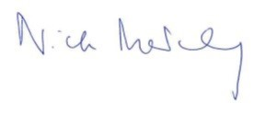
Nick Moberly
Chief Executive

July 2025

